Ideation Phase Empathize & Discover

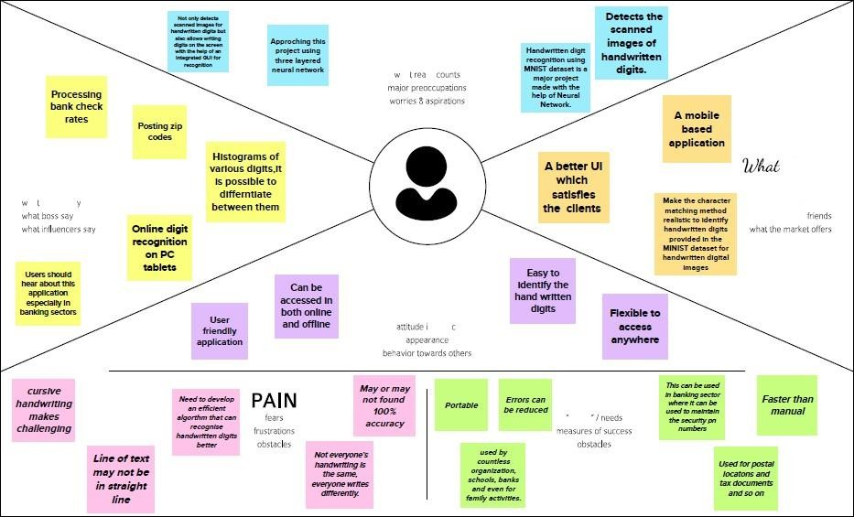

THINK AND FEEL?

ha I iunds sz

SAY AND DO?

GAIN

|  |  |
| --- | --- |
| Date | 19 October 2022 |
| Team ID | PNT2022TMID23664 |
| Project Name | A Novel Method for Handwritten Digit  Recognition System |
| Maximum Marks | 4 Marks |

**Empathy Map:**